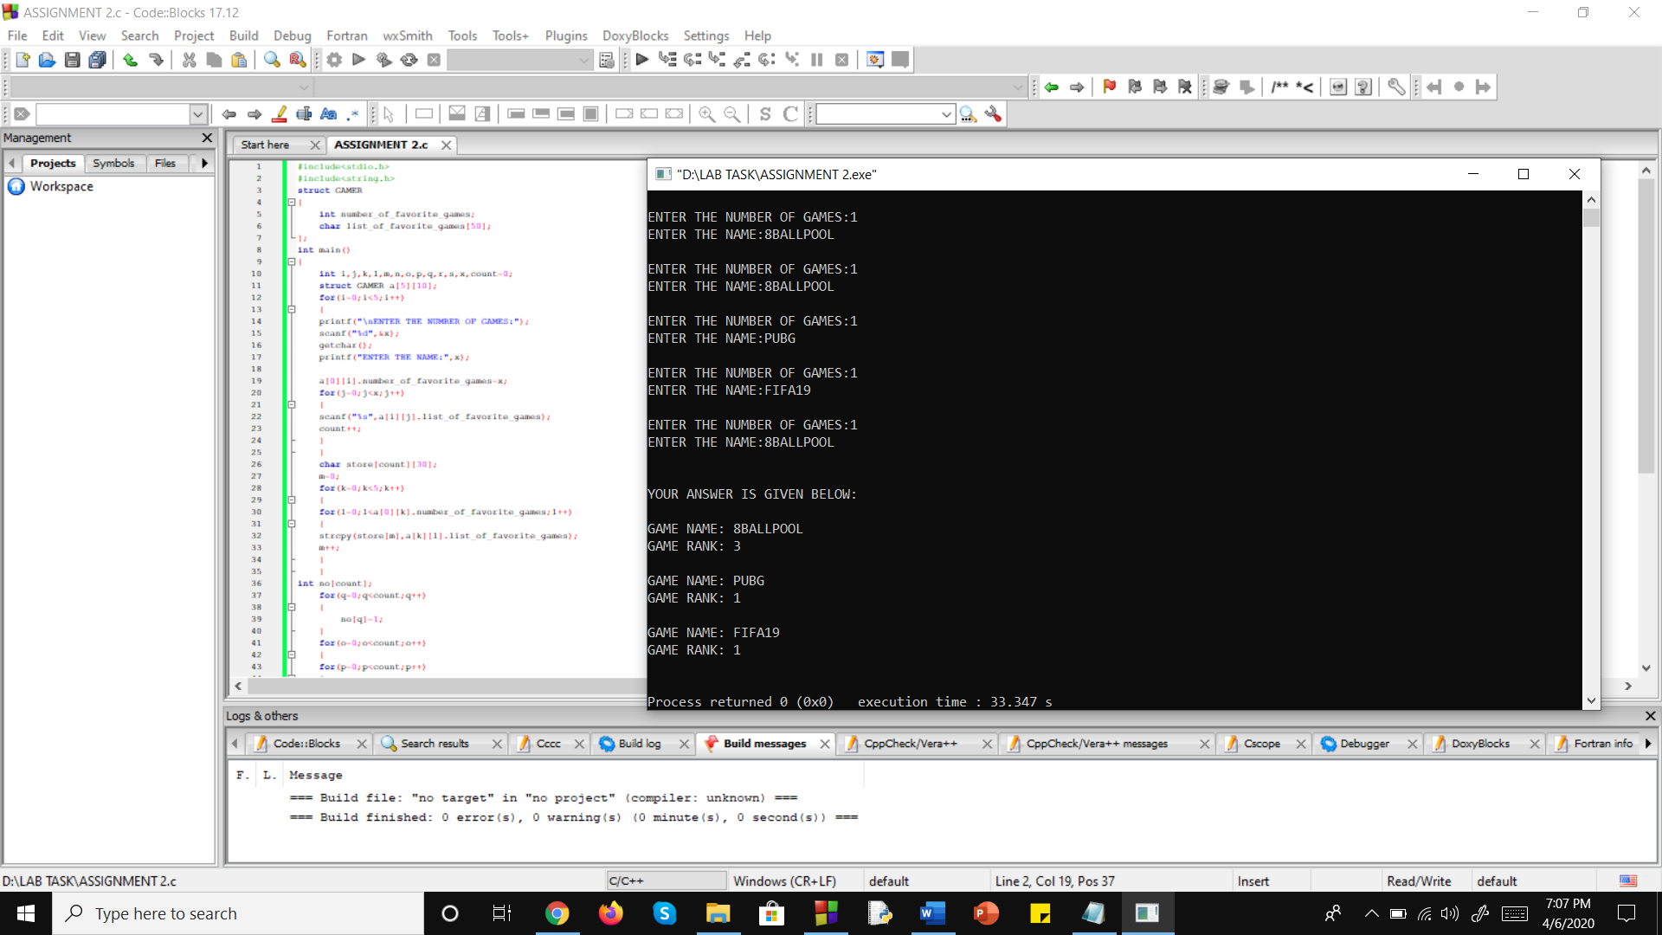**2.ASSIGNMENT NUMBER TWO**

#include<stdio.h>

#include<string.h>

struct GAMER

{

int number_of_favorite_games;

char list_of_favorite_games[50];

};

int main()

{

int i,j,k,l,m,n,o,p,q,r,s,x,count=0;

struct GAMER a[5][10];

for(i=0;i<5;i++)

{

printf("\nENTER THE NUMBER OF GAMES:");

scanf("%d",&x);

getchar();

printf("ENTER THE NAME:",x);

a[0][i].number_of_favorite_games=x;

for(j=0;j<x;j++)

{

scanf("%s",a[i][j].list_of_favorite_games);

count++;

}

}

char store[count][30];

m=0;

for(k=0;k<5;k++)

{

for(l=0;l<a[0][k].number_of_favorite_games;l++)

{

strcpy(store[m],a[k][l].list_of_favorite_games);

m++;

}

}

int no[count];

for(q=0;q<count;q++)

{

no[q]=1;

}

for(o=0;o<count;o++)

{

for(p=0;p<count;p++)

{

if(o!=p && strcmp(store[o],store[p])==0)

{

no[o]=no[o]+1;

for(r=p;r<count;r++)

{

strcpy(store[r],store[r+1]);

}

count--;

}

}

}

printf("\n\nYOUR ANSWER IS GIVEN BELOW:\n\n");

for(s=count;s>0;s--)

{

for(p=0;p<count;p++)

{

if(no[p]>=s)

{

printf("GAME NAME: %s\nGAME RANK: %d\n\n",store[p],no[p]);

no[p]=0;

}

}

}

}